*DSA LAB*

Q1. WAP to create an array that can store max. 50 integers and display the contents of the array.

#include <stdio.h>

void main()

{

int arr[50];

int i,n;

printf("Enter the number of elements in the array :\n");

scanf("%d",&n);

for(i=0; i<n; i++)

{

printf("integer at index %d : ",i);

scanf("%d", &arr[i]);

}

printf("\nElements in array are: ");

for(i=0; i<n; i++)

{

printf("%d ", arr[i]);

}

printf("\n");

}

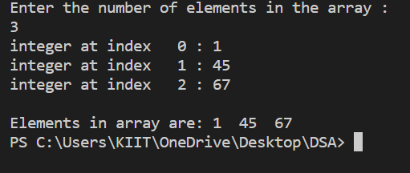

Q2. WAP to find out the sum of the numbers stored in an array of integers.

#include <stdio.h>

void main()

{

int n, sum=0;

printf("Enter the number of elements you want to input: ");

scanf("%d",&n);

int arr[n];

for(int i=0; i<n; i++) {

printf("Enter an integer for index %d: ", i);

scanf("%d",&arr[i]);

}

printf("\n\nThe integers entered are: \n");

for(int i=0; i<n; i++)

{

printf("%d\n",arr[i]);

sum+=arr[i];

}

printf("\nSum of the elements is %d", sum);

}

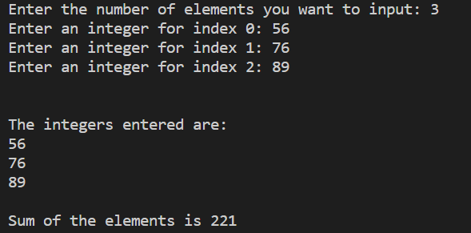

Q3. WAP to find largest and smallest element stored in an array.

#include<stdio.h>

int main()

{

int a[50],i,n,large,small;

printf("\nEnter the number of elements : ");

scanf("%d",&n);

printf("\nInput the array elements : ");

for(i=0;i<n;++i)

scanf("%d",&a[i]);

large=small=a[0];

for(i=1;i<n;++i)

{

if(a[i]>large)

large=a[i];

if(a[i]<small)

small=a[i];

}

printf("\nThe smallest element is %d\n",small);

printf("\nThe largest element is %d\n",large);

return 0;

}

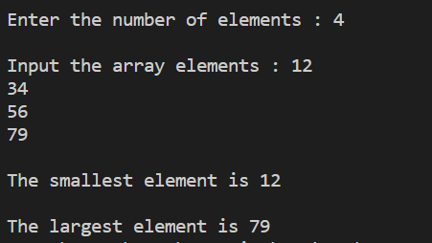

Q4. WAP to display the array elements in ascending order.

#include <stdio.h>

void main ()

{

int num[20];

int i, j, a, n;

printf("enter number of elements in an array\n");

scanf("%d", &n);

printf("Enter the elements\n");

for (i = 0; i < n; ++i)

scanf("%d", &num[i]);

for (i = 0; i < n; ++i)

{

for (j = i + 1; j < n; ++j)

{

if (num[i] > num[j])

{

a = num[i];

num[i] = num[j];

num[j] = a;

}

}

}

printf("The numbers in ascending order is:\n");

for (i = 0; i < n; ++i)

{

printf("%d\n", num[i]);

}

}

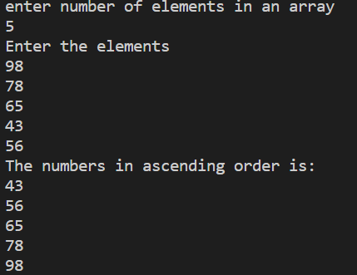

Q5.WAP Input N element into an array.find out sum of all even number and multiply all odd no.

#include <stdio.h>

void main()

{

int i,n,oddmultiplication=1,evenSum=0;

printf("Enter the number of elements you want to input: ");

scanf("%d",&n);

int a[n];

for(int i=0; i<n; i++) {

printf("Enter an integer for index %d: ", i);

scanf("%d",&a[i]);

}

printf("\n\nThe integers entered are: \n");

for(i=0; i<n; i++)

{

if(a[i]%2==0)

{

evenSum=evenSum+a[i];

}

else{

oddmultiplication=oddmultiplication\*a[i];

}

}

printf("The multiplication of all odd numbers are: %d",oddmultiplication);

printf("\nThe sum of even numbers are: %d",evenSum);

}

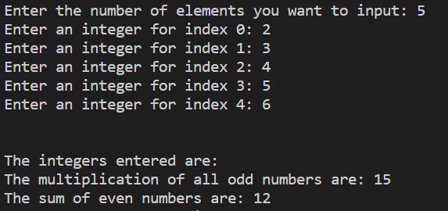

Q6. WAP to search a particular number from the array.

#include <stdio.h>

int main()

{

int a[100],i,n,k;

printf("Enter number of the element in array : ");

scanf("%d", &n);

printf("Enter elements in array : ");

for(i=0; i<n; i++)

{

scanf("%d",&a[i]);

}

printf("Enter the key : ");

scanf("%d", &k);

for(i=0; i<n; i++)

{

if(a[i]==k)

{

printf("element found ");

return 0;

}

}

printf("element not found");

}

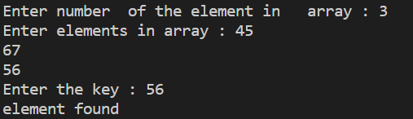

Q7.WAP to remove a specific element from the array.

#include<stdio.h>

void main()

{

int key,n, i, index = -1;

printf("Enter number of element in array:");

scanf("%d",&n);

int a[n];

for(int i=0; i<n; i++)

{

printf("Enter an integer for index %d: ", i);

scanf("%d",&a[i]);

}

printf("Enter element to delete\n");

scanf("%d",&key);

for(i = 0; i < n; i++)

{

if(a[i] == key)

{

index = i;

break;

}

}

if(index != -1)

{

for(i = index; i < n - 1; i++)

a[i] = a[i+1];

printf("New Array : ");

for(i = 0; i < n - 1; i++)

printf("%d ",a[i]);

}

else

printf("Element Not Found\n");

}

OUTPUT

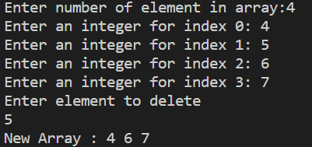

Q8.WAP to insert a new element in a specified position in the array.

#include<stdio.h>

int main()

{

int n, i, pos, num;

printf("Enter number of elements:");

scanf("%d",&n);

int a[n];

printf("Enter integer numbers\n", (n));

for(i = 0; i < (n); i++)

scanf("%d", &a[i]);

printf("Enter the position where new number has to be inserted\n");

scanf("%d", &pos);

if(pos < n)

{

printf("Enter a new number to be inserted at position %d\n", pos);

scanf("%d", &num);

for(i = n; i > pos; i--)

a[i] = a[i - 1];

a[pos] = num;

printf("Array after inserting %d at position %d\n", num, pos);

for(i = 0; i < n; i++)

printf("%d\n", a[i]);

}

else

{

printf("cannot be inserted ");

}

printf("\n");

return 0;

}

OUTPUT

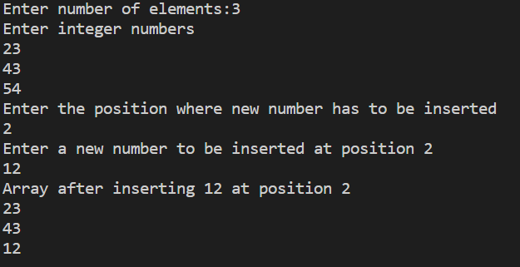

Q9.WAP to remove duplicates from the Array.

#include <stdio.h>

int main ()

{

int i, j, k,n;

printf ("Enter the number of elements in an array: ");

scanf (" %d", &n);

int a[n];

printf (" \n Enter elements of an array: \n ",n);

for ( i = 0; i <n; i++)

{

scanf (" %d", &a[i]);

}

for ( i = 0; i <n; i ++)

{

for ( j = i + 1; j <n; j++)

{

if ( a[i] == a[j])

{

for ( k = j; k <- 1; k++)

{

a[k] = a [k + 1];

}

n--;

j--;

}

}

}

printf (" \n Array elements after deletion of the duplicate elements: ");

for ( i = 0; i <n; i++)

{

printf (" %d \t", a[i]);

}

return 0;

}

OUTPUT

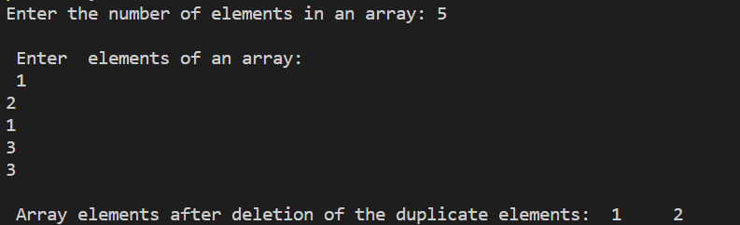

Q10.WAP to store numbers into an array of n integers, where the array must contain some duplicates.

Find out the most repeating element in the array.

#include <stdio.h>

int main()

{

int arr[] = {1, 2, 3, 4, 2, 7, 8, 8, 3};

int length = sizeof(arr) / sizeof(arr[0]);

printf("Duplicate elements in given array: \n");

for (int i = 0; i < length; i++)

{

for (int j = i + 1; j < length; j++)

{

if (arr[i] == arr[j])

{

printf("%d\n", arr[j]);

}

}

}

return 0;

}

OUTPUT

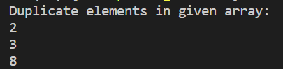

*RISHIKESH*

*CSE 32*

*2105734*